* **Backend**

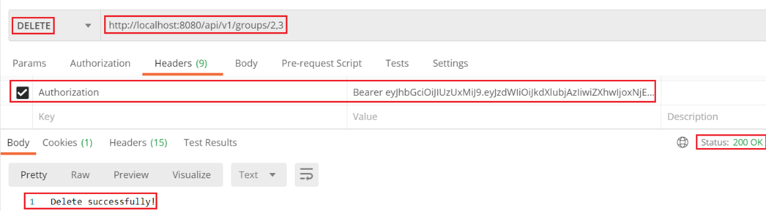

*Bỏ qua validate ở backend*

* **Frontend**

|  |  |
| --- | --- |
|  |  |

* + Multiple selection
    - <https://react-bootstrap-table.github.io/react-bootstrap-table2/storybook/index.html?selectedKind=Row%20Selection&selectedStory=Multiple%20Selection&full=0&addons=1&stories=1&panelRight=0&addonPanel=storybook%2Factions%2Factions-panel>
    - <https://react-bootstrap-table.github.io/react-bootstrap-table2/storybook/index.html?selectedKind=Row%20Selection&selectedStory=Selection%20Management&full=0&addons=1&stories=1&panelRight=0&addonPanel=storybook%2Factions%2Factions-panel>
  + Chỉnh sửa thêm nút Refresh Form
* **Reference**